1. Filtering an order and clicking the correct operation line will refresh all grids in POE and in PAK 🡪 **this is ok**.



2. Clicking the Change Work Station -button will refresh all the grids in POE and in PAK 🡪 **NOT OK**.



3. Pressing the Change Allocation -button will refresh all the grids in POE and in PAK 🡪 **NOT OK**.

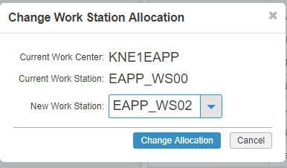

4. After pressing the Change Allocation -button **in POE** the operation line is no more selected (this issue is not in PAK) so in POE I need press once again on the operation line which will get the grids to refresh again 🡪 **NOT OK**.



5. Pressing Start -button will refresh all the grids in POE and in PAK 🡪 **NOT OK**.

